Instructions for Accepting Your Financial Aid Award in CUNYFirst

1.At the GC Portal, located at https://www.gc.cuny.edu/GC-Header/GC-Portal, click onCUNYFirst, which will bring you to https://cunyfirst.cuny.edu.

2. From the Home screen on CUNYFirst, click on Student Center.

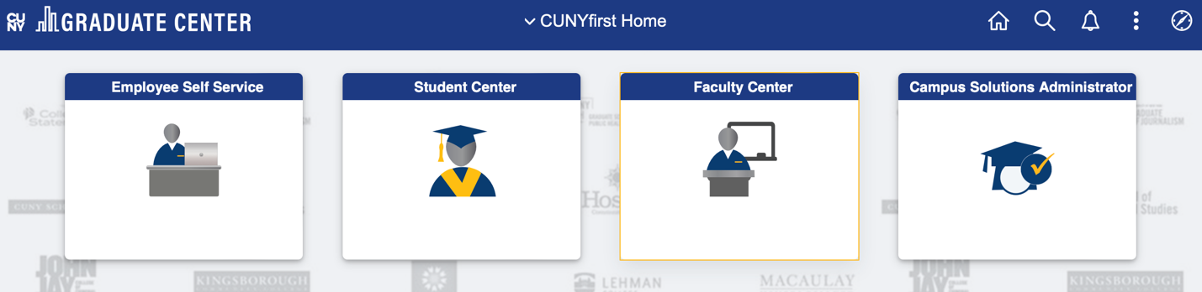

3. Scroll down and click the financial aid tab.

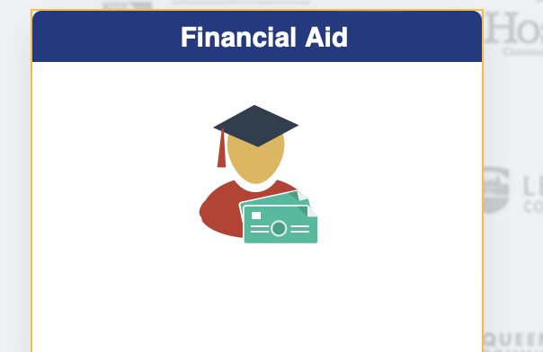

4. Once you are in the financial aid portal you should see your Award Summary.

5. Under Awards (on the left menu), click on the tab that says Accept/Decline. Your awards should be listed.

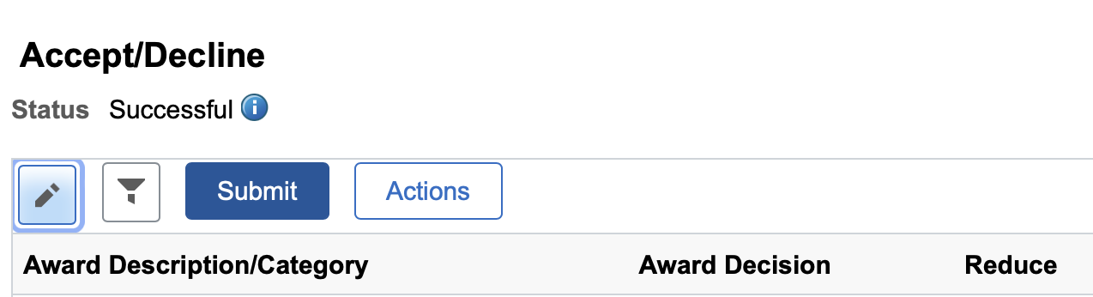

6. Click the edit button on the top left hand corner. Each award should be highlighted with a drop down menu. Click accept or decline on each individual award.

7. When you are finished accepting/declining your award. Click Submit. The system will record your decision.

